**LIBRARY MODULE – SHARED LIBRARY**

**1. Create 3 files as below.**

**· libapplication.c – will contain main() and will invoke functions in cal_utility.c**

**A:** Command used---**vi libapplication.c**

**· cal_utility.c – will contain atleast 2 or more functions [ You may add definitions of the functions in this file ]**

**A:**Command used---**vi cal_utility.c**

**· cal_utility.h – will contain the extern declarations/prototypes of the functions in cal_utility.c**

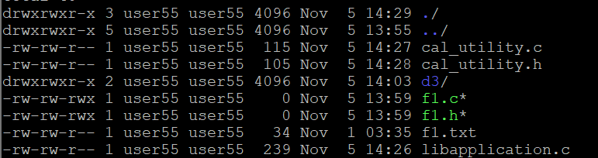

**2. Refer the steps for shared library and create a shared library comprising of cal_utility.c,.h files**

**3. Create an executable using shared library.**

**A:** Command used---- **gcc libapplication.c cal_utility.c -o my_program**

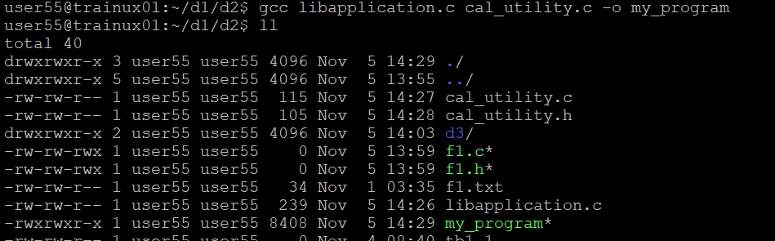

**4. Execute the application created step 3.**

**A:** Command used----./**my_program**

